Web Performance Review
Differences Between Real and Perceived Performance
- Perceived Performance: This is how users perceive the performance of a website. It's how they evaluate it in terms of responsiveness and reliability. This is a subjective measurement, so it's hard to quantify it, but it's very important, since the user experience determines the success or failure of a website.
- Real Performance: This is the objective and measurable performance of the website. It's measured using metrics like page load time, server response time, and rendering time. These measurements are influenced by multiple factors related to the network and to the code itself.
Techniques for Improving Perceived Performance
- Lazy Loading: This technique reduces the initial load time as much as possible by loading non-essential resources in the background.
- Minimize Font Delays: If your website has custom fonts, you should also try to minimize font loading delays, since this may result in flickering or in showing the fallback font while the custom font is being loaded. A suggestion for this is using a fallback font that is similar to the custom font, so in case this happens, the change will be more subtle.
- Use of Loading Indicators: Showing a loading indicator for a long-running process as soon as the user clicks on an element can help the user feel connected and engaged with the process, making the wait time feel shorter.
Core Performance Concepts
- Source order: This refers to the way HTML elements are structured in the document. This determines what loads first and can significantly impact performance and accessibility.
Some best practices for source order include:
- Placing critical content such as headings, navigation or main text higher in the HTML structure.
- Deferring non-essential scripts such as ones for analytics, or third-party widgets, so they don't block rendering.
- Using progressive enhancement, to ensure the core experience works even before styles and scripts load. Progressive enhancement is a way of building websites and applications based on the idea that you should make your page work with HTML first.
Here is an example of good source order, using the best practices we just went through:
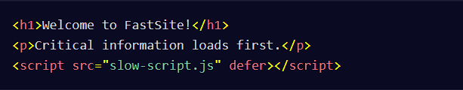
- Critical Rendering Path: This is the sequence of steps the browser follows to convert code into pixels on the screen.
- Latency: This is the time it takes for a request to travel between the browser and the server. So in other words, high latency equals slow pages.
Some ways of reducing latency include:
- Using CDNs, or Content Delivery Networks, to serve files from closer locations.
- Enabling compression using things such as Gzip to reduce file sizes.
- Optimizing images and using lazy loading.
Improving INP
- Definition: INP (Interaction to Next Paint) assesses a page's overall responsiveness by measuring the time from when a user interacts, like a click or key press, to the next time the browser updates the display. A lower INP indicates a more responsive page.
Here are some ways to improve INP:
- Reduce main thread work by breaking up long JavaScript tasks.
- Use requestIdleCallback() for non-critical scripts. This will queue a function to be called during a browser's idle periods.
- Defer or lazy-load heavy assets which were covered earlier.
- Optimize event handlers. If these handlers run too frequently or perform heavy operations, they can slow down the page and increase INP. The solution for this is debouncing. Debouncing ensures that the function only runs after the user stops typing for a short delay - so for example 300ms. This prevents unnecessary calculations and improves performance.
How Rendering Works in the Browser
- How Rendering works: First the browser parses the HTML and builds the DOM. Next, the browser processes the CSS, constructing the CSS Object Model, or CSSOM. This is another tree structure that dictates how elements should be styled. Finally, the browser paints the pixels to the screen, rendering each element based on the calculated styles and layout. In complex pages, this might involve multiple layers that are composited together to form the final visual output.
How Performance Impacts Sustainability
- Background Information: The internet accounts for around 2% of global carbon emissions—that's the same as the airline industry! Every byte transferred requires electricity, from data centers to user devices. Larger files and inefficient scripts mean more power consumption. A high-performance website isn't just faster, it also reduces unnecessary processing and energy use.
Ways to Reduce Page Loading Times
- Optimize Media Assets: Large images and videos are common culprits for slow load times. By optimizing these assets, you can significantly speed up your site. This includes things like compressing images, using modern formats like WebP and using lazy loading for assets.
- Leverage Browser Caching: Caching allows browsers to store parts of your website locally, reducing load times for returning visitors.
- Minify and Compress Files: Reducing the size of your files can lead to quicker downloads. This includes reducing the size of transmitted files and minifying CSS and JavaScript files.
Improving "time to usable"
- Definition: "time to usable" is the interval from when a user requests a page to when they can meaningfully interact with it. To improve "time to usable" you can lazy load your asset or minimize render-blocking resources.
Key Metrics for Measuring Performance
- First Contentful Paint or FCP: It measures how quickly the first piece of content—text or image—appears on the screen. A good FCP is regarded as a time below 1.8 seconds, and a poor FCP is above 3 seconds. You can check your FCP using Chrome DevTools and checking the performance tab.
- Total Blocking Time: This shows how long the main thread is blocked by heavy JavaScript tasks. If Total Blocking Time (TBT) is high, users experience sluggish interactions. To improve TBT, break up long tasks and defer non-essential scripts.
- Bounce Rate: This is the percentage of visitors who leave without interacting. If your site has high bounce rates it might be because your page is too slow.
- Unique Users: This metric tracks how many individual visitors come to your site. To view the Bounce Rate and Unique Users, you can use Google Analytics. It will allow you to monitor these metrics and improve engagement.
Common Performance Measurement Tools
- Chrome DevTools: Chrome DevTools is a built-in tool inside Google Chrome that lets you analyze and debug performance in real-time. DevTools will show loading times, CPU usage, and render delays. It's especially useful for measuring First Contentful Paint, or FCP, is how fast a user sees the first visible content. If your website feels slow, DevTools will help you spot the bottlenecks.
- Lighthouse: This is an automated tool that checks performance, SEO, and accessibility.
- WebPageTest: This tool lets you test how your site loads from different locations and devices. This tool gives you a detailed breakdown of your site's Speed Index, Total Blocking Time, and other key performance metrics. If you want to know how real users experience your site globally, WebPageTest is the tool for that.
- PageSpeed Insights: This tool analyzes your website and suggests quick improvements for both mobile and desktop. It will tell you what's slowing your site down and give specific recommendations like optimizing images, removing render-blocking scripts, and reducing server response times. PageSpeed Insights is a fast and easy way to check how Google sees your site's performance.
- Real User Monitoring: RUM tools track actual user behavior, showing how real visitors experience your site. Popular RUM tools include Google Analytics, which tracks page load times and bounce rates, and New Relic or Datadog, which monitor real-time performance issues. If you want data from actual users, RUM tools are essential.
Working with Performance Web APIs
- Definition: Performance Web APIs let developers track how efficiently a webpage loads and responds directly in the code. These APIs allow you to measure page load times, track rendering and interaction delays and analyze JavaScript execution time.
- performance.now(): This API gives you high-precision timestamps (in milliseconds) to measure how long different parts of your site take to load.
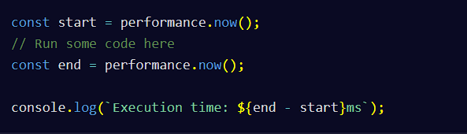
- Performance Timing API: This API gives you a breakdown of every stage of page loading, from DNS lookup to DOMContentLoaded.
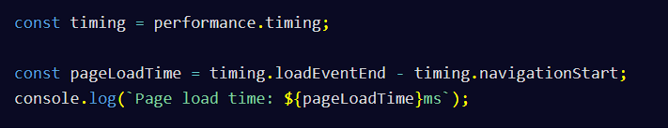
- PerformanceObserver: This API listens for performance events such as layout shifts, long tasks, and user interactions.
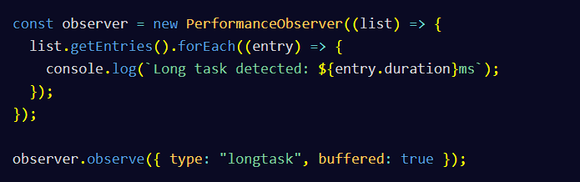
Techniques for Improving CSS Performance
- CSS Animations: Animating certain CSS properties, such as dimensions, position, and layout, triggers a process called "reflow", during which the browser recalculates the position and geometry of certain elements on the page. This requires a repaint, which is computationally expensive. Therefore, it's recommended to reduce the number of CSS animations as much as possible or at least give the user an option to toggle them on or off.
Techniques for Improving JavaScript Performance
- Code Splitting: Splitting your JavaScript code into modules that perform critical and non-critical tasks is also helpful. This way, you'll be able to preload the critical ones as soon as possible and defer the non-critical ones to render the page as fast as possible.
- DOM Manipulation: Remember that DOM Manipulation refers to the process of dynamically changing the content of a page with JavaScript by interacting with the Document Object Model (DOM). Manipulating the DOM is computationally expensive. By reducing the amount of DOM manipulation in your JavaScript code will improve performance.

Testing Review
Manual and Automated Testing
- Manual Testing: In manual testing, a tester will manually go through each part of the application and test out different features to make sure it works correctly. If any bugs are uncovered in the testing process, the tester will report those bugs back to the software team so they can be fixed.
- Automated Testing: In automated testing, you can automate your tests by writing a separate program that checks whether your application behaves as expected.
Unit Testing
- Unit Testing: In unit testing, you test each function to ensure that everything is working as expected. Unit tests can also serve as a form of documentation for your application because they are meant to represent the expected behavior for your code.
- Single Responsibility Principle: The single responsibility principle recommends keeping each function small and responsible for one thing.
- Common JavaScript Testing Frameworks: Some common testing frameworks include Jest, Mocha, and Vitest. Jest is a popular testing framework for unit tests.
Here is an example of unit tests using Jest.
First, you can create a function that is responsible for returning a newly formatted string:
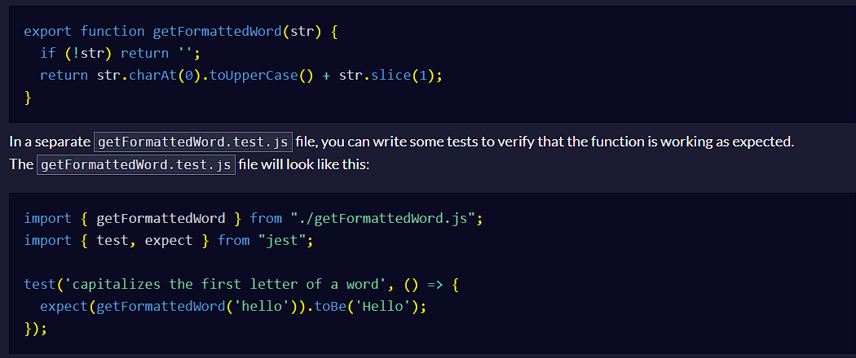
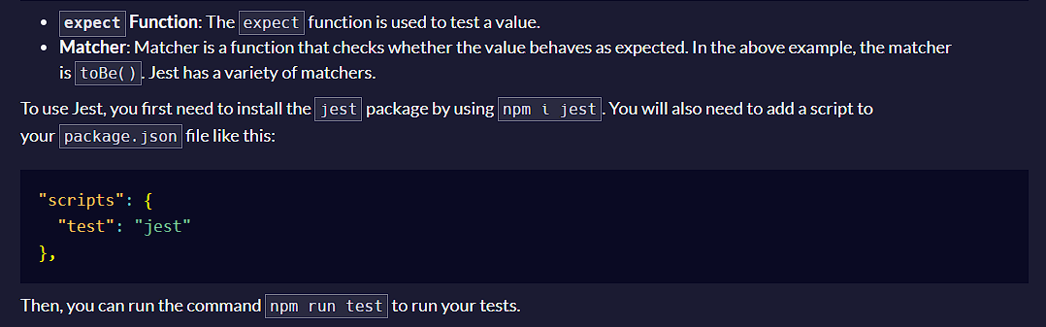
Software Development Lifecycle
- Different Stages of Software Development Lifecycle:
  - Planning Stage: The development team collects requirements for the proposed work from the stakeholders.
  - Design Stage: The software team breaks down the requirements and decides on the best approaches for solutions.
  - Implementation Stage: The software team breaks down the requirements into manageable tasks and implements them.
  - Testing Stage: This involves manual and automated testing for the new work. Sometimes, the team tests out the application throughout the entire development stage to catch and fix any issues that come up.
  - Deployment Stage: The team deploys the new changes to a build or testing environment.
  - Maintenance Stage: This involves fixing any issues that arise from customers in the production application.
- Different Models of the Software Development Lifecycle:
  - Waterfall Model: The Waterfall model is where each phase of the lifecycle needs to be completed before the next phase can begin.
  - Agile Model: The Agile model focuses on iterative development by breaking down work into sprints.
BDD and TDD
- TDD: Test-driven development is a methodology that emphasizes writing tests first. Writing tests before building out features provides real-time feedback to developers during the development process.
- BDD: Behavior-driven development is the approach of aligning a series of tests with business goals. The test scenarios in BDD should be written in a language that can be understood by both technical and non-technical individuals. An example of such syntax is Gherkin.
- BDD Testing Frameworks: Examples of BDD testing frameworks include Cucumber, JBehave, and SpecFlow.
Assertions in Unit Testing
- Assertion: Assertions are used to test that the code is behaving as expected.
- Assertion Libraries: Chai is a commonly used assertion library. Other common JavaScript assertion libraries are should.js and expect.js.
Here is an example of an assertion using Chai that checks that the return value from the addThreeAndFour function is equal to the number 7:
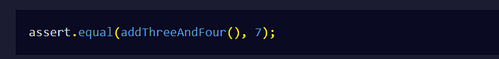
- Best Practices: Regardless of which assertion library you use, you should write clear assert and failure messages that will help you understand which tests are failing and why.
Mocking, Faking, and Stubbing
- Mocking: Mocking is the process of replacing real data with false data that simulates the behavior of real components. For example, you could mock the API response in testing instead of making continuous API calls to fetch the data.
- Stubbing: Stubs are objects that return pre-defined responses or dummy data for an expected behavior in an application. For example, you can stub the behavior for a database connection in your tests without having to rely on an actual database connection.
- Faking: Fakes are simplified versions of real components without the complexity or side effects. For example, you can fake a database by storing the data in memory instead of interacting with the real database. This will allow you to mimic database operations in memory, which will be much faster than dealing with the real database.
Functional Testing
- Functional Testing: Functional testing checks if the features and functions of the application work as expected. The goal of functional testing is to test the system as a whole against multiple scenarios.
- Non-Functional Testing: Non-functional testing focuses on things like performance and reliability.
- Smoke testing: Smoke testing is a preliminary check on the system for basic or critical issues before beginning more extensive testing.
End-to-End Testing
- End-to-End Testing: End-to-end testing, or E2E, tests real-world scenarios from the user's perspective. End-to-end tests help ensure that your application behaves correctly and is predictable for users. However, it is time-consuming to set up, design, and maintain.
- End-to-End Testing Frameworks: Playwright is a popular end-to-end testing framework developed by Microsoft. Other examples of end-to-end testing tools include Cypress, Selenium, and Puppeteer.
Here is an example of E2E tests from the freeCodeCamp codebase using Playwright. The beforeEach hook will run before each of the tests. The tests check that the donor has a supporter link in the menu bar, as well as a special stylized border around their avatar:
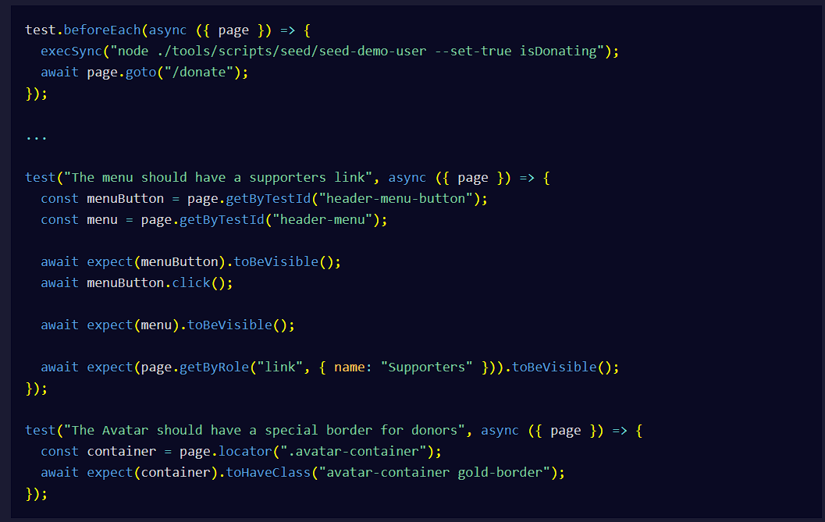
Usability Testing
- Usability Testing: Usability testing is when you have real users interacting with the application to discover if there are any design, user experience, or functionality issues in the app. Usability testing focuses on the intuitiveness of the application by users.
- Four Common Types of Usability Testing:
  - Explorative: Explorative usability testing involves users interacting with the different features of the application to better understand how they work.
  - Comparative: Comparative testing is where you compare your application's user experience with similar applications in the marketplace.
  - Assessment: Assessment testing is where you study how intuitive the application is to use.
  - Validation: Validation testing is where you identify any major issues that will prevent the user from using the application effectively.
- Usability Testing Tools: Examples of tools for usability testing include Loop11, Maze, Userbrain, UserTesting, and UXTweak.
Compatibility Testing
- Compatibility Testing: The goal of compatibility testing is to ensure that your application works in different computing environments.
- Different Types of Compatibility Testing:
  - Backwards Compatibility: Backwards compatibility refers to when the software is compatible with earlier versions.
  - Forwards Compatibility: Forwards compatibility refers to when the software and systems will work with future versions.
  - Hardware Compatibility: Hardware compatibility is the software's ability to work properly in different hardware configurations.
  - Operating Systems Compatibility: Operating systems compatibility is the software's ability to work on different operating systems, such as macOS, Windows, and Linux distributions like Ubuntu and Fedora.
  - Network Compatibility: Network compatibility means the software can work in different network conditions, such as different network speeds, protocols, security settings, etc.
  - Browser Compatibility: Browser compatibility means the web application can work consistently across different browsers, such as Google Chrome, Safari, Firefox, etc.
  - Mobile Compatibility: It is important to ensure that your software applications work on a variety of Android and iOS devices, including phones and tablets.
Performance Testing
- Performance Testing: In performance testing, you test an application's speed, responsiveness, scalability, and stability under different workloads. The goal is to resolve any type of performance bottleneck.
- Different Types of Performance Testing:
  - Load Testing: Load testing determines how a system behaves during normal and peak load times.
  - Stress Testing: Stress testing is where you test your application in extreme loads and see how well your system responds to the higher load.
  - Soak Testing (Endurance Testing): Soak testing or endurance testing is a type of load testing where you test the system with a higher load for an extended period of time.
  - Spike Testing: Spike testing is where you dramatically increase and decrease the loads and analyze the system's reactions to the changes.
  - Breakpoint Testing (Capacity Testing): Breakpoint testing or capacity testing is where you slowly increment the load over time to the point where the system starts to fail or degrade.
Security Testing
- Security Testing: Security testing helps identify vulnerabilities and weaknesses.
- Security Principles:
  - Confidentiality: This protects against the release of sensitive information to other recipients that aren't the intended recipient.
  - Integrity: This involves preventing malicious users from modifying user information.
  - Authentication: This involves verifying the user's identity to ensure that they are allowed to use that system.
  - Authorization: This is the process of determining what actions authenticated users are allowed to perform or which parts of the system they are permitted to access.
  - Availability: This ensures that information and services are available to authorized users when they need it.
  - Non-Repudiation: This ensures that both the sender and recipient have proof of delivery and verification of the sender's identity. It protects against the sender denying having sent the information.
- Common Security Threats:
  - Cross-Site Scripting (XSS): XSS attacks happen when an attacker injects malicious scripts into a web page and then executes them in the context of the victim's browser.
  - SQL Injection: SQL injection allows malicious users to inject malicious code into a database.
  - Denial-of-Service (DoS) Attack: DoS attack is when malicious users flood a website with a high number of requests or traffic, causing the server to slow down and possibly crash, making the site unavailable to users.
- Categories of Security Testing Tools:
  - Static Application Security Testing: These tools evaluate the source code for an application to identify security vulnerabilities.
  - Dynamic Application Security Testing: These tools interface with the application's front-end to uncover potential security weaknesses. DAST tools do not have access to the source code.
- Penetration Testing (pentest): Penetration testing is a type of security testing that involves creating simulated cyberattacks on the application to identify any vulnerabilities in the system.
A/B Testing
- A/B Testing: A/B testing involves comparing two versions of a page or application and studying which version performs better. It is also known as bucket or split testing. A/B testing allows you to make more data-driven decisions and continually improve the user experience.
- Tools for A/B Testing: Examples of tools to use for A/B testing include GrowthBook and LaunchDarkly.
Alpha and Beta Testing
Once the initial development and software testing are complete, it is important to have the application tested by testers and real users. This is where alpha and beta testing come in.
- Alpha Testing: Alpha testing is done by a select group of testers who go through the application to ensure there are no bugs before it is released into the marketplace. Alpha testing is part of acceptance testing and utilizes both white and black box testing techniques.
- Beta Testing: Beta testing is where the application is made available to real users. Users can interact with the application and provide feedback. Beta testing is also a form of user acceptance testing.
- Acceptance Testing: Acceptance testing ensures that the software application meets the business requirements and the needs of users before its release.
- Black Box Testing: Black box testing only focuses on the expected behavior of the application.
- White Box Testing: White box testing involves the tester knowing the internal components and performing tests on them.
Regression Testing
- Regression: Regression refers to situations where new changes unintentionally break existing functionality.
- Regression Testing: Regression testing helps catch regression issues. In regression testing, you re-run functional tests against parts of your application to ensure that everything still works as expected.
- Tools for Regression Testing: Tools that you can use to perform regression testing include Puppeteer, Playwright, Selenium, and Cypress.
- Techniques for Regression Testing:
  - Unit Regression Testing: This is where you have a list of items that need to be tested each time major changes or fixes are implemented into the app.
  - Partial Regression Testing: This involves targeted approaches to ensure that new changes have not broken specific aspects of the application.
  - Complete Regression Testing: This runs tests against all the functionalities in the codebase. This is the most time-consuming and detailed option.
- Retesting: Retesting is used to check for known issues and ensure that they have been resolved. In contrast, regression testing searches for unknown issues that might have occurred through recent changes in the codebase.

